**Hybrid Cloud Services Project Proposal**

**Vision and Goals Of The Project:**

Hybrid cloud model has a foreseeable future, because two types of clouds offer drastically different properties (security, performance, bursting capability, features, etc.)

Hybrid model is hard to build and manage (lots of concerns, network connectivity, security, user interaction, etc.) The aim of this project is to lay foundation for creating a completely seamless world, that developers just focus on building application logic, and the infrastructure layer would automatically handle scaling, placing and manage different components on either or both clouds.

A modest goal of this project is to understand the challenges of the hybrid cloud model. A more ambitious one is to come up with a working example of allowing developers to deploy an application that span both clouds (and they don't even know it.)

**Users/Personas of The Project**

Hybrid cloud services will be used by researchers from different Universities, industries and government institutions which plan to opt for hybrid cloud.

**Scope and Features of the Project:**

High-Level features of this project include

Realistic:

* Understanding the challenges of the hybrid cloud model
  + Identifying security constraints during data migrations from private to public clouds
  + Partitioning application between private and public clouds
  + Communication between public and private cloud
* Exploring the options to overcome these challenges
* Writing a research paper manuscript for the project findings

Ambitious:

* Finding way to transfer data from private cloud to a public cloud as securely as possible (VPN)
* Storing this data such that it is not reachable by unauthorized users
* Processing this data on the public cloud and passing the data back to the private cloud securely
* Defining a model/abstraction with auto-scaling mechanism that developer can interact with the system
* Enabling software developers to automatically deploy an application (code and dependency configuration) that span both clouds without the user knowing the switch between the clouds
* Providing a feedback mechanism to inform the developer about the actual deployed state of the app

**Solution concept/architecture:**

Understanding following cloud functionalities in order to achieve hybrid cloud services:

* Different APIs/services that are exposed by private clouds
* Services of public cloud that can consume private cloud services
* Various modes of connection between the two
* Ways to make the connection secure and private like using VPN, etc.
* Data migration

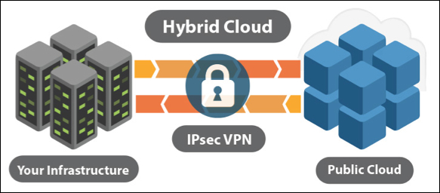

**Design implications:**

We will update design implication as the research progresses.

**Acceptance Criteria:**

We would have explored the challenges and the related work done and written the research paper manuscript.

**Release Planning:**

We are doing bi-weekly Sprint planning with weekly updates to the mentors.